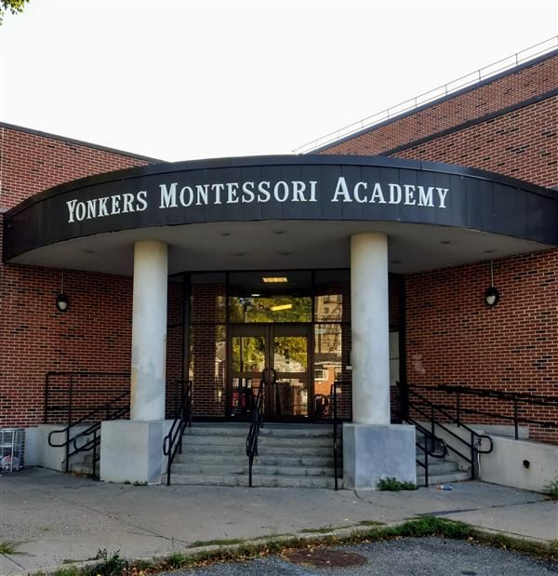

MINIMUM CAPACITY :-
The Minumum intake capacity
of students is between 300-620
children

LIBRARY :-
The Libarary is Available.

CANTEEN:-
The Canteen Facility is Available.

BOARDING :-
No availablility of boarding.

SPORTS :-
There are different categories
sports available.
Girls Volleyball
Boys Volleyball
Football

YONKERS MONTESSORI ACADEMY
YONKERS - SCHOOL

School Detail :-
The students, parents, staff and community of the Patricia A. DiChiaro School are committed to academic excellence in a positive learning environment. All students will achieve high standards in this safe and creative atmosphere. At the Patricia A. DiChiaro School collaboration and cooperation successfully prepare our students for the future

.

